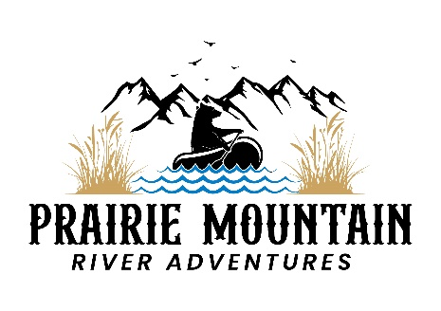

**River Rations**

**(Includes: Dessert, Fruit Cup, choice of Pasta Salad, Potato Salad, Veggie Salad, or bag of chips, and choice of Sandwich or Salad. Water and assorted non-alcoholic drinks are complementary with your journey)**

Gourmet Viddles

**Deli Italian Roast Beef**

Roast Beef with provolone cheese, topped with banana peppers, red onions, roasted red peppers and shredded lettuce seasoned with house blend of spices and Italian dressing.

**The Pressed Italian**

Layers of pesto, provolone cheese, salami, ham, mozzarella, pepperoni, and roasted red peppers are pressed in the middle of a crusty ciabatta roll.

**Jive Turkey**

Ciabatta bread topped with shaved turkey breast over mild cheddar cheese, thinly sliced red onion with crispy bacon, sliced avocado and baby spinach make up this hearty sandwich.

**Dirty Hippie**

Stacks of veggies on top of a base layer of hummus. Sprinkled with Feta cheese- take it as a wrap or sandwich.

Farmer Grub

**Get Him To The Greek Salad**

A bed of spring greens and topped with chopped cucumber, tomatoes, red onion, bell peppers, black olives, feta cheese, banana peppers and roasted chicken breast. Served with a greek vinaigrette.

Plate Fillers

Seasonal Fruit Cup

Choice of Pasta Salad, Potato Salad, Veggie Salad, or Bagged Chips

Goodies

Fresh Baked--Varies Daily

